**LAB 1: Tensile Testing of Metals**

Keyvan Yeganeh - 23988165

Ratthamnoon Prakitpong - 63205165

Section C

Lab Date: September 27, 2017

**Summary**

In this lab, a gradually increasing force was applied across Brass and Steel rods, while we observed the relationship between the force applied, and the elongation of each rod. Through a Load Vs. Extension plot we then viewed each rods behaviour, specifically noting the yield point, ultimate stress, and fracture point. The results of the experiment were as expected, since each rod went through the phases of elastic elongation, and then plastic deformation. Once the ultimate stress was reached, each rod began necking, ultimately reaching the fracture point and breaking into two pieces. Although the acquired numerical values for the moduli of elasticity were lower than expected, these values can be justified through explanation of the sources of error. (Refer to question 7)

**Procedure**

1. Measure initial length of brass and steel rods. After making length indicating marks, place one of the rods in the tensometer. Start the tensometer. Collect and analyse data. Repeat with the other rod.
2. Place bass cantilever on it constraining jig. Measure the horizontal length on the cantilever and its initial height from the ground. Place weight on the end of the horizontal length and measure its final height from the ground. Analyse data. Repeat with steel cantilever.

Note: For data point extrapolation, brass was done manually with the offset method, drawing lines parallel to the elastic area of the curve, while steel was done by digitally tracing the curve to find the needed points, then using the calculated slope of elastic area of the curve to find the offset of the other points. Hence, the more precise points in figure 2 compared to figure 1.

**Results**

Table 1: Tensile Testing Data

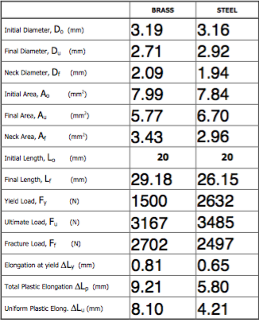

**Table 2: Cantilever Beam Measurement and Calculations (See Appendix A for sample calculations)**

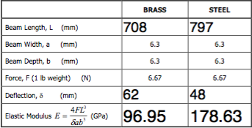

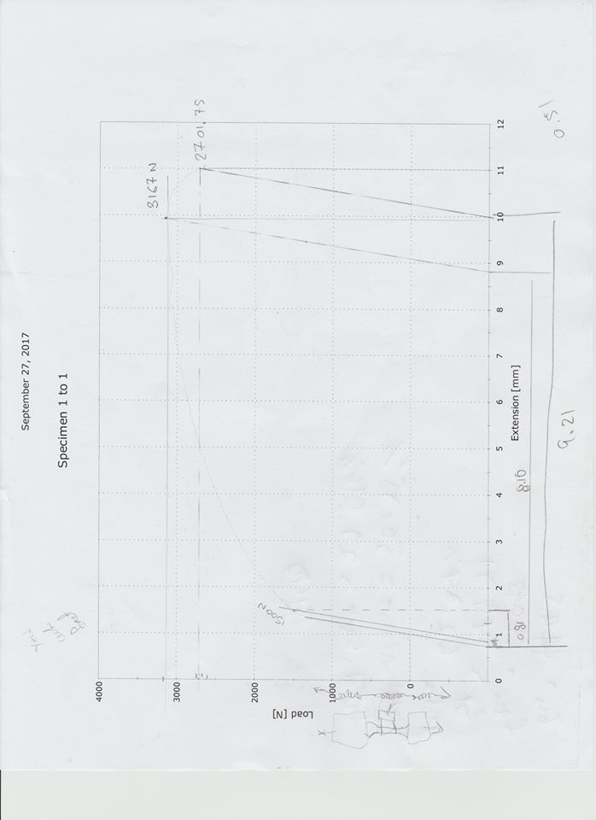

**Figure 1: Force Vs. Elongation Curve for Brass**

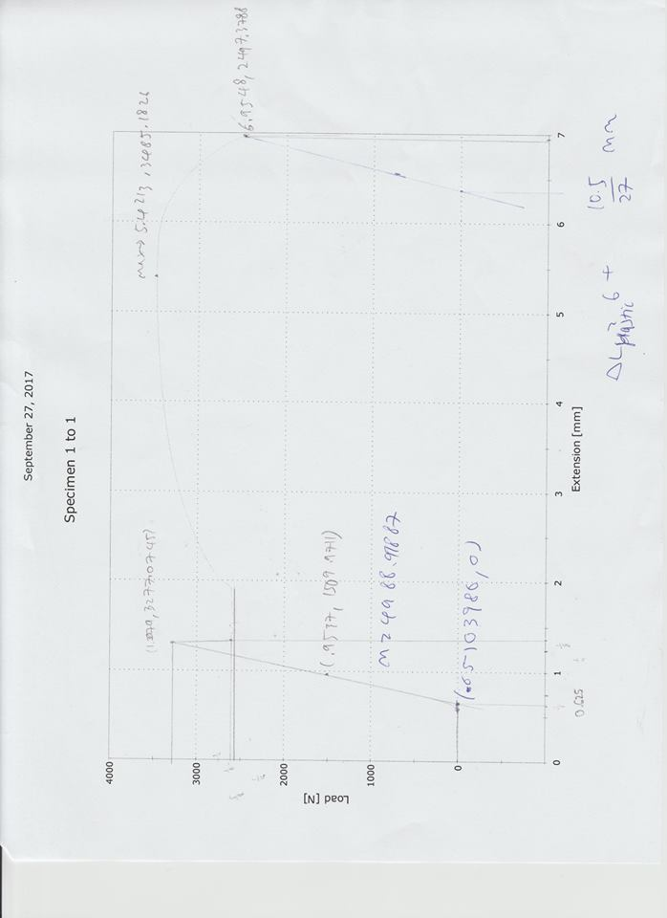

**Figure 2: Force Vs. Elongation Curve for Steel**

**Questions:**

1.

**Table 3: Tensing Testing Calculations (See Appendix A for sample calculations)**



2. The modulus of resistance is a representation of how much stress can be applied to a material before plastic deformation begins, that being the total energy per unit volume absorbed by the metal up to the yield point.

Brass = 179,412 J/m^3

Steel = 274,865 J/m^3

(See Appendix A for sample calculations)

3. Toughness of Brass: 134.49 e6

Toughness of Steel: 113.19 e6

Toughness is the ability for a material to absorb energy without fracturing. Comparing this to the modulus of resistance, the toughness takes into account the stress applied up to a point of fracture rather than up to the point of plastic deformation. It can be seen that while steel had the higher modulus of resistance, brass has a higher toughness value. This is because brass is a more ductile metal, and thus can withstand a higher intake of energy per unit volume before fracturing.

(See Appendix A for sample calculations)

4. True Strain at ultimate stress point:

Brass: 0.3255

Steel: 0.157

True strain at fracture point:

Brass: 0.846

Steel: 0.974

(See Appendix A for calculations)

5. Engineering Strain at necking point:

Brass: 0.385

Steel: 0.170

(See Appendix A for calculations)

6. Calculations show that percent elongation for 20mm specimen is 29%, while the 40mm specimen’s percent elongation would be 25%(See Appendix A for calculations). That is because elongation is uniform only up until ultimate stress, thus the elongation at necking is not uniform and becomes independent of initial specimen length.

7. Comparing the elastic modulus obtained from the tensile test to that obtained in the cantilever test and the theoretical values, it can be seen that the elastic modulus obtained in the tensile test is significantly lower than what was expected. This is because when the tensometer is measuring the elongation values, it is actually measuring the elongation of both the metal specimen and the machine itself. When a high load is applied from the back of the machine, the parts of the Instron tensometer holding the metal piece will also begin to stretch. This means that the elongations values on the graph are actually much larger than the elongations values for the metal test piece. These high elongation values will make the calculated strain higher than what it should be, thus making the calculated elastic modulus lower than expected, since the modulus of elasticity is defined as stress/strain. To avoid this source of systematic error, an extensometer can be used. The extensometer will make it so that the measured strain is only that of the metal test piece, thus making the obtained modulus of elasticity significantly more accurate.

8. When comparing Brass and Steel in terms of heterogenous of homogenous yielding, it is observed that while brass undergoes homogeneous yielding, steel yields heterogeneously, thus having a clear yield point between elastic and plastic deformation. This phenomenon known as the yield point phenomenon is due to the carbon impurities present in steel. While brass is a pure substance and has a smooth transition between elastic and plastic deformation, steel is made of iron and carbon, thus having an upper and lower yield point, and a clear transition between its phases of elastic and plastic deformation.

**Appendix A: Sample Calculations**

Brass:

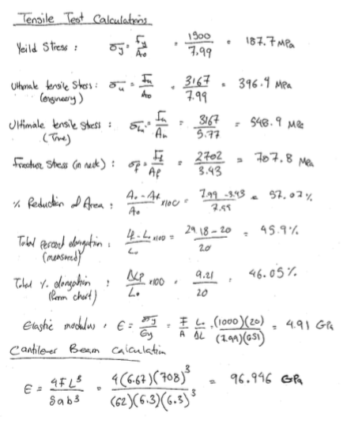

Steel:

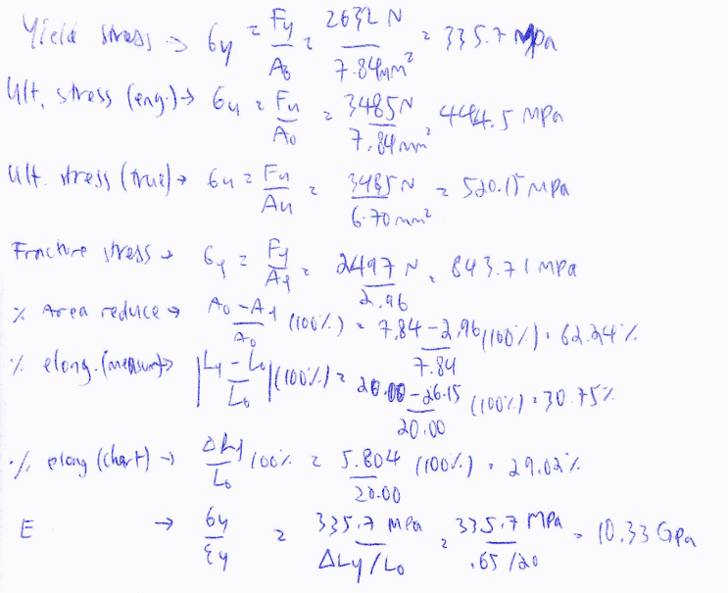

Note: There were no uncertainty calculations as there was only one data point each collected for brass and steel samples.

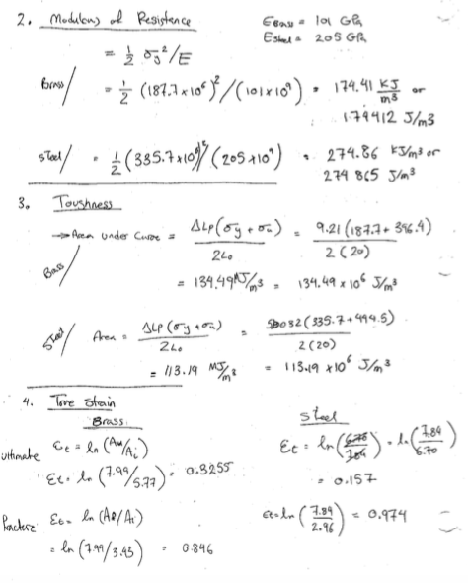

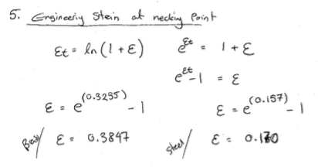

6. 